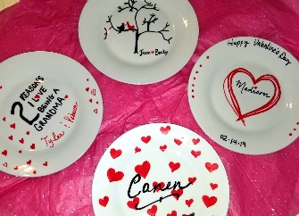
Valentine Fundraiser
HERE’S HOW IT ALL WORKS

- WSA will send out the Fundraiser Order Forms to your selected School Designee.

- It is recommended students be given at least a week with their order form (but this is at the school’s discretion.)

- All Forms and one check totaling the complete order amount are returned to (credit and debit cards are also accepted online):

Well-being Safety Assessments, LLC 104 Rockhill Court Saint Robert, Missouri 65584 Attention: Valentine Plates

- Our local artists will get busy making every order specifically as requested. It typically takes 1-2 weeks to complete the order. Please ensure all orders are plainly written so no personalization mistakes will be made.

- Once completed, all orders will be mailed directly to the School Designee with an invoice showing a credit for the specific amount that can be used toward the School Wellness Assessment.

**Schools opting to only do the fundraiser with no assessment will receive a check totaling the amount the School profited on the fundraiser.

Schools selling over the amount of the School Wellness Assessment will be credited for future assessments.

All plates are hand-painted by local artists in the Mid-West. They are signed and numbered. Although all plates have a specific look and saying, each plate will be different due to being handcrafted.

